**JAYPEE UNIVERSITY OF INFORMATION TECHNOLOGY**

**WAKNAGHAT**

**Operating Systems Lab**

**Lab Assignment dated 24.01.2022**

**Name -** Akash Kumar Singh

**Roll no -** 201460

**Batch -** CS 48

**Task 1: WAP to display the following pattern on output screen using fork( ) system call:**

**1. Your Name (1 time)**

**2. Your Roll Number (2 times)**

**3. University Name (4 times)**

**Code:**

#include<iostream>

#include<unistd.h>

using namespace std;

int main()

{

cout<<"Akash Kumar Singh\n";

fork();

cout<<"Roll number: 201460\n";

fork();

cout<<"Jaypee University of Information Technology, Waknaghat\n";

return 0;

}

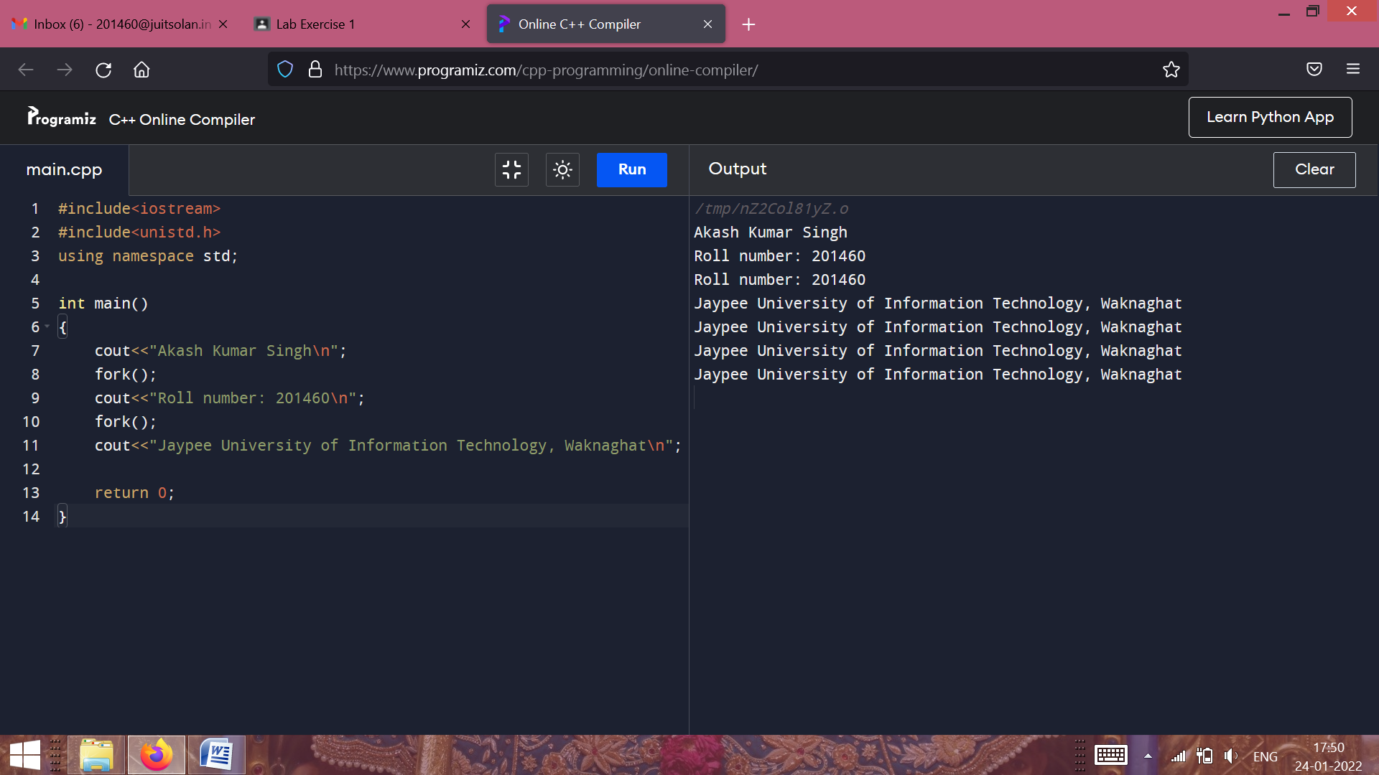

**Task 2: WAP that creates a child process using fork( ) system call. Store the value returned in an integer variable. Display two different messages: “Hey, Hello: I am the child process” as well as “Hey, Hello: I am the parent process” using the variable value.**

**Code:**

#include<iostream>

#include<unistd.h>

using namespace std;

int main()

{

int rvalue;

rvalue=fork();

if(rvalue<0)

cout<<"The returned value is negative\n";

else if(rvalue==0)

cout<<"Hey, Hello: I am the Child Process.\n";

else

cout<<"Hey, Hello: I am the Parent Process.\n";

return 0;

}

